The Ecosystem Lab Name___________________________
Ecosystems are a complex and delicate balancing game. The addition or removal of one species affects many other species with which it might compete for, or provide food. In this lab, you will get a chance to “build your own” ecosystem, and explore the effects of these interrelationships.
Go to the link: http://www.learner.org/courses/envsci/interactives/ecology
Part 1: Explain how 2 plant species interact in an ecosystem
Procedure:
- Click on Lesson 1: The Producers. Read “Challenge”
- In the upper right you’ll see “Open Simulator.” Click and open the simulator
- Plant A and Plant B will be on. Click on Plant B and choose the check to remove Plant B from the simulator.
- Click “Run” on the simulator for Plant A alone. Record your data below on the mini-graph. Give a possible explanation for your graphed results.
________________________________________________________________________________________
________________________________________________________________________________________
________________________________________________________________________________________
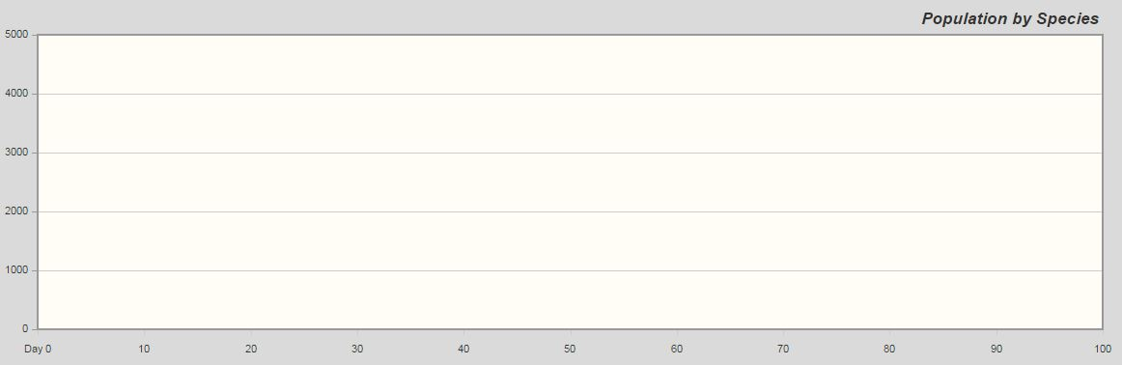
- Hit Reset. Now uncheck Plant A and check Plant B to run the simulator for Plant B alone. Graph your results. Make sure to label your lines or provide a key.
- Make a hypothesis. What do you suppose will occur if Plant A and Plant B are run in the same ecosystem?
________________________________________________________________________________________
________________________________________________________________________________________
________________________________________________________________________________________
- Turn on both Plant A and Plant B and run the simulation. Graph your results.
- Do you find one producer to be dominant? Why might one producer be dominant over another in an ecosystem?
________________________________________________________________________________________
________________________________________________________________________________________
________________________________________________________________________________________
Part 2: Introducing herbivores, you will try to create a scenario where both species can coexist in the same ecosystem
Now you’ll introduce an herbivore into the environment with Plant A and Plant B. In theory, an herbivore native to the ecosystem should feed primarily on the dominant species. In this system, the herbivore may consume enough of the dominant species to give the non-dominant species a chance for proliferation and survival.
- Click on Herbivore A (rabbit) and choose “eats Plant A.” Using your knowledge from Part 1, predict what will happen to the population of Plant A.
________________________________________________________________________________________

________________________________________________________________________________________

________________________________________________________________________________________
- Run the simulator and record your results.

- Does adding the herbivore establish a more equal field?
________________________________________________________________________________________
- Is one producer still dominant over the other?
________________________________________________________________________________________

- Why might one producer be dominant over another?
________________________________________________________________________________________

________________________________________________________________________________________

________________________________________________________________________________________
- If the simulation included decomposers, how would your current results change?
________________________________________________________________________________________

________________________________________________________________________________________

________________________________________________________________________________________
- How do producer population numbers with the presence of an herbivore compare to the producer populations from Part 1?
________________________________________________________________________________________

________________________________________________________________________________________

________________________________________________________________________________________
Part 3: Create a food web that allows a community to thrive
When the ecosystem contains plants only, one species of plant out-competes the other(s) and takes over. This illustrates the “competitive exclusion principle” which theorizes that no two species can occupy the same niche at the same time in a particular locale if resources are limited. The presence of a consumer is needed to keep that plant in check and allow the other species to survive.
The primary colonizers of an ecosystem, the producers, are also the forerunners of primary succession. As these primary plants die and decay, they add organic material to the soil, which, over time, will allow for secondary succession—generally larger and more delicate producers such as trees.
Now that you have a sense for the interrelationships between the trophic levels, see how big you can make your food web and still have all of the species you add survive through the end of the simulation run. Keeping the idea of succession and the competitive exclusion principle in mind, think of the many factors that may go into sustaining an ecosystem. Is there any way we can all live side by side?
- Run as many simulations and scenarios as possible in order to find the best balance in your ecosystem.
- When you find the beast balance, summarize what each feeds on in the data table and graph your results.

Species | Feeds on:
Herbivore A
Herbivore B
Herbivore C
Omnivore A
Omnivore B
Top Predator
- What would happen to this imaginary ecosystem if the producers were to die out?
________________________________________________________________________________________

________________________________________________________________________________________

- Did any of these species increase in number? What could account for this increase?
________________________________________________________________________________________

________________________________________________________________________________________

- Which species decreased in number and what might account for this decrease?
________________________________________________________________________________________

________________________________________________________________________________________

- Were you able to modify the parameters so that each species survived? Explain how you decided what changes to make.
________________________________________________________________________________________

________________________________________________________________________________________

